## Task1:

### Code:

#include <stdio.h>

#include <pthread.h>

#include <unistd.h>   // ✅ getpid() ke liye include karna zaroori hai

#define NUM_THREADS 4

int varg = 0;

void *thread_function(void *arg) {

    int thread_id = *(int *)arg;

    int varl = 0;

    varg++;   // global variable increment

    varl++;   // local variable increment

    printf("Thread %d is executing. Global value = %d | Local value = %d | Process ID = %d\n",

           thread_id, varg, varl, getpid());

    return NULL;

}

int main() {

    pthread_t threads[NUM_THREADS];

    int thread_args[NUM_THREADS];

    for (int i = 0; i < NUM_THREADS; ++i) {

        thread_args[i] = i;

        pthread_create(&threads[i], NULL, thread_function, &thread_args[i]);

    }

    for (int i = 0; i < NUM_THREADS; ++i) {

        pthread_join(threads[i], NULL);

    }

    printf("Main is executing. Final Global value = %d | Process ID = %d\n", varg, getpid());

    return 0;

}

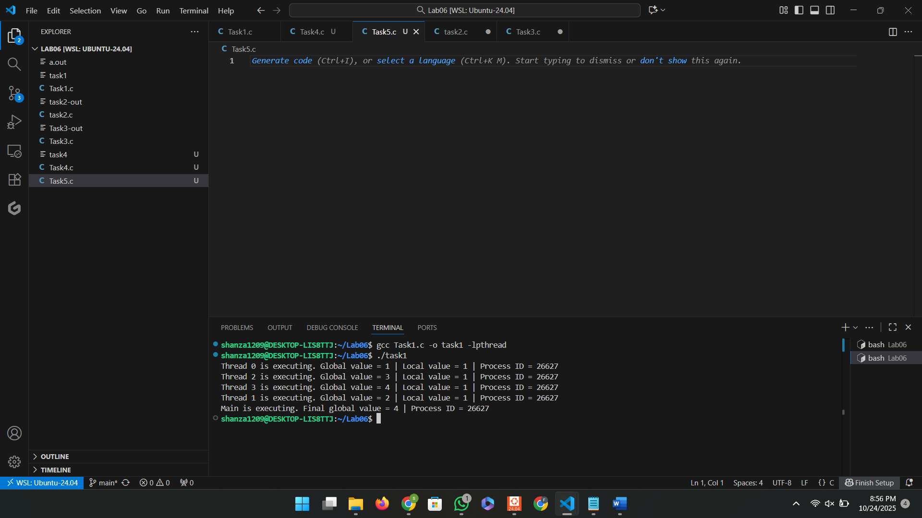

## Task2:

### Code:

#include <stdio.h>

#include <pthread.h>

#include <unistd.h>

#define NUM_ITERATIONS 1000000

int count=10;

// Critical section function

void critical_section(int process) {

    //printf("Process %d is in the critical section\n", process);

    //sleep(1); // Simulate some work in the critical section

    if(process==0){

        for (int i = 0; i < NUM_ITERATIONS; i++)

        count--;

    }

    else

    {

        for (int i = 0; i < NUM_ITERATIONS; i++)

        count++;

    }

}

void *process0(void *arg) {

        // Critical section

        critical_section(0);

        // Exit section

    return NULL;

}

void *process1(void *arg) {

        // Critical section

        critical_section(1);

        // Exit section

    return NULL;

}

int main() {

    pthread_t thread0, thread1, thread2, thread3;

    // Create threads

    pthread_create(&thread0, NULL, process0, NULL);

    pthread_create(&thread1, NULL, process1, NULL);

    pthread_create(&thread2, NULL, process0, NULL);

    pthread_create(&thread3, NULL, process1, NULL);

    // Wait for threads to finish

    pthread_join(thread0, NULL);

    pthread_join(thread1, NULL);

    pthread_join(thread2, NULL);

    pthread_join(thread3, NULL);

    printf("Final count: %d\n", count);

    return 0;

}

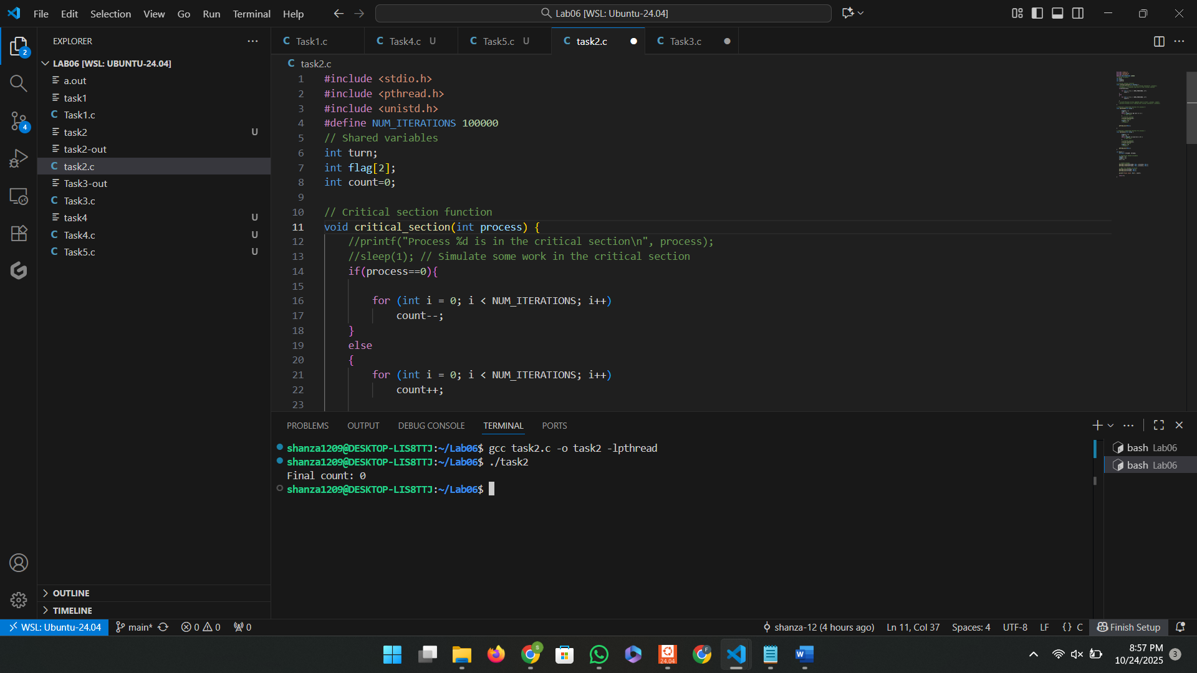

## Task3:

### Code:

## #include <stdio.h>

## #include <pthread.h>

## #include <unistd.h>

## #define NUM_ITERATIONS 1000000

## int count=10;

## pthread_mutex_t mutex; // mutex object

## // Critical section function

## void critical_section(int process) {

## //printf("Process %d is in the critical section\n", process);

## //sleep(1); // Simulate some work in the critical section

## if(process==0){

## for (int i = 0; i < NUM_ITERATIONS; i++)

## count--;

## }

## else

## {

## for (int i = 0; i < NUM_ITERATIONS; i++)

## count++;

## }

## //printf("Process %d has updated count to %d\n", process, count);

## //printf("Process %d is leaving the critical section\n", process);

## }

## // Peterson's Algorithm function for process 0

## void *process0(void *arg) {

## 

## pthread_mutex_lock(&mutex); // lock

## // Critical section

## critical_section(0);

## // Exit section

## 

## pthread_mutex_unlock(&mutex); // unlock

## 

## return NULL;

## }

## // Peterson's Algorithm function for process 1

## void *process1(void *arg) {

## 

## 

## pthread_mutex_lock(&mutex); // lock

## // Critical section

## critical_section(1);

## // Exit section

## pthread_mutex_unlock(&mutex); // unlock

## 

## 

## return NULL;

## }

## int main() {

## pthread_t thread0, thread1, thread2, thread3;

## pthread_mutex_init(&mutex,NULL); // initialize mutex

## // Create threads

## pthread_create(&thread0, NULL, process0, NULL);

## pthread_create(&thread1, NULL, process1, NULL);

## pthread_create(&thread2, NULL, process0, NULL);

## pthread_create(&thread3, NULL, process1, NULL);

## // Wait for threads to finish

## pthread_join(thread0, NULL);

## pthread_join(thread1, NULL);

## pthread_join(thread2, NULL);

## pthread_join(thread3, NULL);

## pthread_mutex_destroy(&mutex); // destroy mutex

## printf("Final count: %d\n", count);

## return 0;

## }

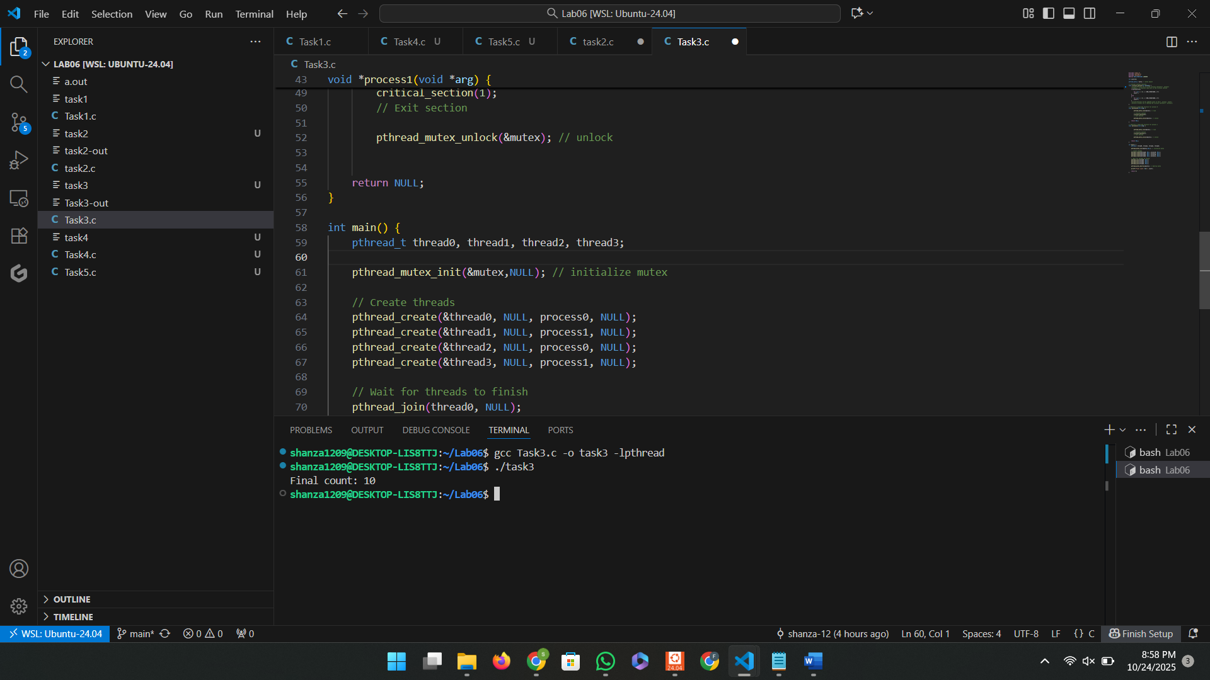

## Task4:

### Code:

#include <stdio.h>

#include <pthread.h>

#include <unistd.h>

#define NUM_ITERATIONS 1000000

int count = 10;

pthread_mutex_t mutex; // mutex object

// Critical section function

void critical_section(int process) {

    if (process == 0) {

        for (int i = 0; i < NUM_ITERATIONS; i++)

            count--;

    }

    else if (process == 1) {

        for (int i = 0; i < NUM_ITERATIONS; i++)

            count++;

    }

    else if (process == 2) {

        for (int i = 0; i < NUM_ITERATIONS; i++)

            count += 2;  // third process modifies differently

    }

}

// Process 0

void *process0(void *arg) {

    pthread_mutex_lock(&mutex);   // lock

    critical_section(0);

    pthread_mutex_unlock(&mutex); // unlock

    return NULL;

}

// Process 1

void *process1(void *arg) {

    pthread_mutex_lock(&mutex);

    critical_section(1);

    pthread_mutex_unlock(&mutex);

    return NULL;

}

// ✅ Process 2 (newly added)

void *process2(void *arg) {

    pthread_mutex_lock(&mutex);

    critical_section(2);

    pthread_mutex_unlock(&mutex);

    return NULL;

}

int main() {

    pthread_t thread0, thread1, thread2, thread3, thread4, thread5;

    pthread_mutex_init(&mutex, NULL); // initialize mutex

    // Create threads for all processes

    pthread_create(&thread0, NULL, process0, NULL);

    pthread_create(&thread1, NULL, process1, NULL);

    pthread_create(&thread2, NULL, process2, NULL);

    pthread_create(&thread3, NULL, process0, NULL);

    pthread_create(&thread4, NULL, process1, NULL);

    pthread_create(&thread5, NULL, process2, NULL);

    // Wait for all threads to complete

    pthread_join(thread0, NULL);

    pthread_join(thread1, NULL);

    pthread_join(thread2, NULL);

    pthread_join(thread3, NULL);

    pthread_join(thread4, NULL);

    pthread_join(thread5, NULL);

    pthread_mutex_destroy(&mutex); // destroy mutex

    printf("Final count: %d\n", count);

    return 0;

}

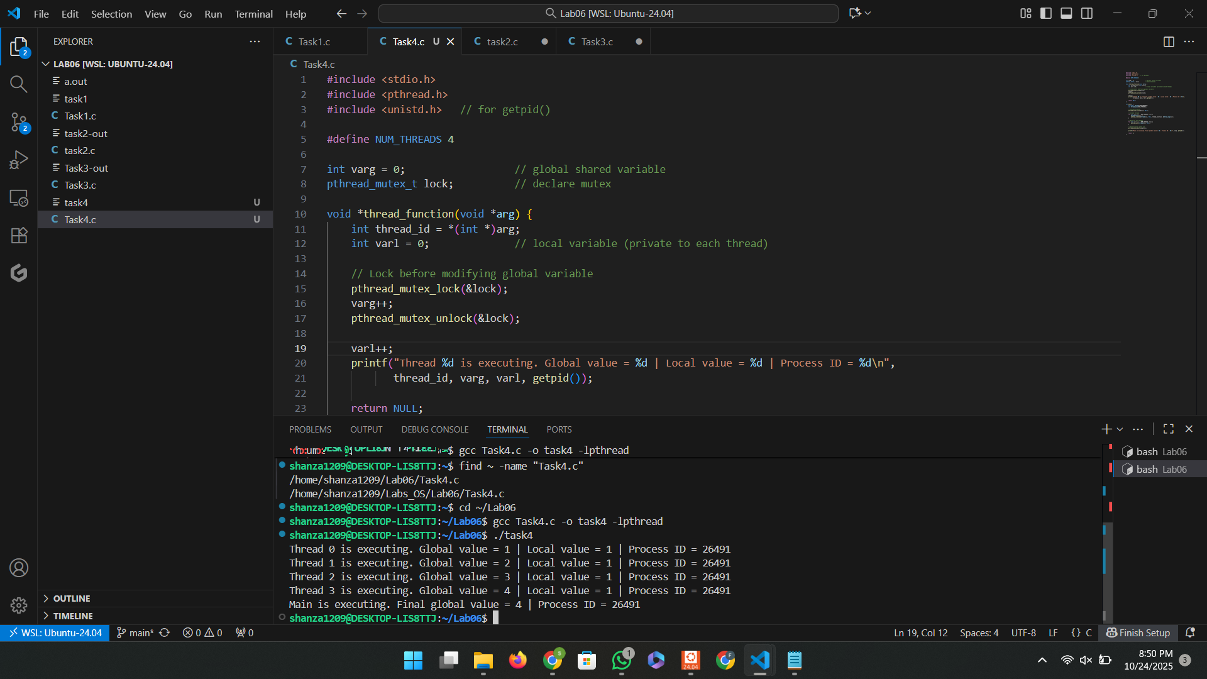

**Comparison of mutex and peterson’s algorithm:**

A mutex is a synchronization mechanism provided by the operating system that allows only one process or thread to access a shared resource at a time. When a process wants to enter its critical section, it locks the mutex, ensuring that no other process can enter until it is unlocked. Once the process finishes its task, it releases the mutex, allowing other processes to proceed. Mutexes are hardware- or OS-supported, making them efficient, reliable, and widely used in real-world systems for handling concurrency and preventing race conditions. A mutex is a hardware or OS-based synchronization tool that ensures only one thread enters the critical section at a time, preventing data inconsistency.

**Peterson’s Algorithm:**

In contrast, Peterson’s algorithm is a software-based solution for achieving mutual exclusion between two processes. It uses two shared variables—flag[] and turn—to coordinate which process can enter the critical section. Each process sets its flag to indicate interest in entering and assigns the turn to the other process. A process only enters its critical section when it is its turn and the other process is not interested. Peterson’s algorithm is a software-based synchronization technique that uses shared variables to ensure mutual exclusion between two processes without hardware support.